Soil Texture
The information used about texture for the Lombardy region in this work was obtained from the website below;
https://www.geoportale.regione.lombardia.it/download-ricerca
The initial classes of the soil texture for the study area is shown in the figure below;

Figure 1: Bar Chart showing the initial soil texture and percentage covered.

Based on the recommendation of Professor Tommaso Chiti, the soil texture was reclassified into just four (4) classes which are basically a combination of the pre-existing classes shown in Figure 3 above:
- Sandy Clay (48.8%): Including the classes Sand (1.51%) and Loamy Sand (4.7%)
- Loam (13.4%)
- Clay Loam (13.3%): Including the classes Clay (3.27%), Sandy Clay Loam (0.15%), Sandy Clay (0.11%)
- Silt Loam (11%): Including the classes Silty Clay Loam (2.4%) and Silty Clay (1.26%).

To perform this reclassification of the soil texture on QGIS, a new field was created on the attribute table of the existing shapefile for the soil texture and was given the name, “TXT_NEW”. Using the Open Field Calculator tool, this field was updated with the code below;

if ( "DESCR_TXT" = 'Franco sabbiosa' OR "DESCR_TXT" = 'Sabbiosa' OR "DESCR_TXT" = 'Sabbioso franca' , 1, if("DESCR_TXT" = 'Franca' ,2, if("DESCR_TXT" = 'Franco argillosa' OR "DESCR_TXT" = 'Argillosa' OR "DESCR_TXT" = 'Franco sabbiosa argillosa' OR "DESCR_TXT" = 'Argillosa sabbiosa' , 3,4)))
Where the number 1 to 4 are the new texture classes which stands for the combination of the soil texture in the numerical order shown below;

1 = Sandy Loam
2 = Loam
3 = Clay Loam
4 = Silt Loam

The only two of the soil texture without a class as seen in Figure 3 with a percentage of 0.04% was assigned to the new class 4 (Silt Loam) by the default after running the line of code above.

A dissolve of this classes was then carried out to have a new map homogenous in terms of this new four (4) texture classes. The result of this dissolve was then saved and the attribute table for the dissolved shapefile was updated and then exported outside QGIS as an excel file saved in the project directory. The statistics in terms of percentage for each new class was then calculated and shown below;

Figure 2: Bar Chart showing the new soil texture classes and area covered in hectare.

Table 1: Soil Texture classes based on area covered in hectares and percentage.
Reclassified Soil Texture | Area (Ha) | Area (%)
Sandy Loam | 1312866.42 | 55.00
Loam | 319918.96 | 13.40
Clay Loam | 402279.18 | 16.85
Silt Loam | 351816.56 | 14.74
Total | 2386881.12

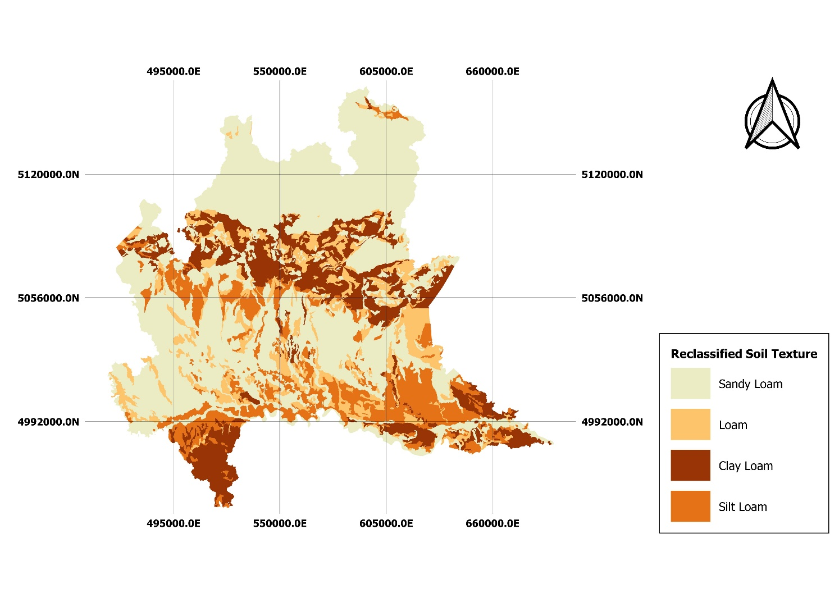
Figure 3: Map showing the new soil texture classes. (EPSG: WGS 84/UTM Zone 32N).

